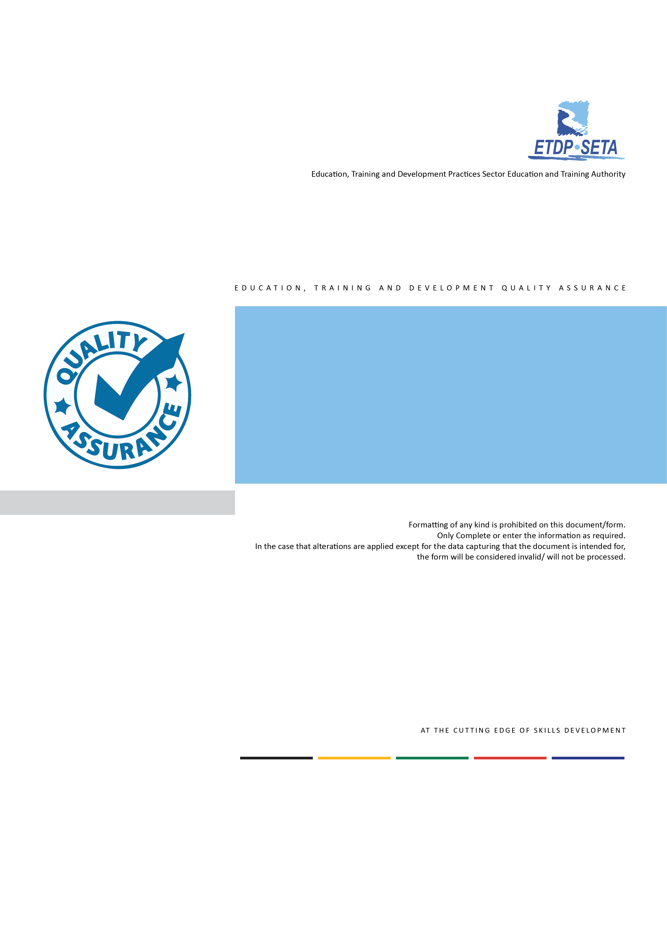
ETDQA
Phase B: Application Form
Contact Learning Mode of Delivery

Section A: Skills Development Provider Information
ETDP SETA Application Number*
ETDP SETA Accreditation Number**
* ETDP SETA Application Number: Applicable to Institutional and Secondary Extension of scope applications.
** ETDP SETA Accreditation Number: Applicable to ETDP SETA accredited SDPs extending their accreditation scope.
Registered Company Name
Trading Company Name
Demographics***  (Majority Shareholder/s) | African |  | Coloured |  | Indian |  | White |  | Other
Demographics***  (Majority Shareholder/s) | Female | Male | Female | Male | Female | Male | Female | Male | Female | Male
Demographics***  (Majority Shareholder/s) | ☐ | ☐ | ☐ | ☐ | ☐ | ☐ | ☐ | ☐ | ☐ | ☐
****Demographics: Only complete one column, which reflects the “Majority Shareholder/s”
Province | EC | FS | GP | KZN | LP | MP | NC | NW | WC
Province | ☐ | ☐ | ☐ | ☐ | ☐ | ☐ | ☐ | ☐ | ☐
Application Type |  |  |  |  |  | Yes | No
Institution Accreditation: Applicant not yet accredited by another QAP and/ or QCTO. |  |  |  |  |  | ☐ | ☐
Extension of Accreditation Scope: Applicant is already accredited by the ETDP SETA, another QAP and/ or QCO. |  |  |  |  |  | ☐ | ☐

Section B: Learning Materials
B1: Learning Material Design and Development
Source of Learning Materials |  |  |  | Status of “Purchased Learning Materials”
Developed in-house |  | Purchased |  | Purchased Learning Materials Approved by the ETDP SETA
Yes | No | Yes | No | Yes | No | Not Applicable
☐ | ☐ | ☐ | ☐ | ☐ | ☐ | ☒
B2: Learning Material Evidence
Required Evidence
Valid Purchase Agreement (Applicable to applicants submitting “Purchased Learning Materials)
Valid ETDP SETA Learning Approval Letter
(Applicable to “Purchased Learning Materials” with an approval status granted by the ETDP SETA in the past twelve (12) months from the date of the application submission)

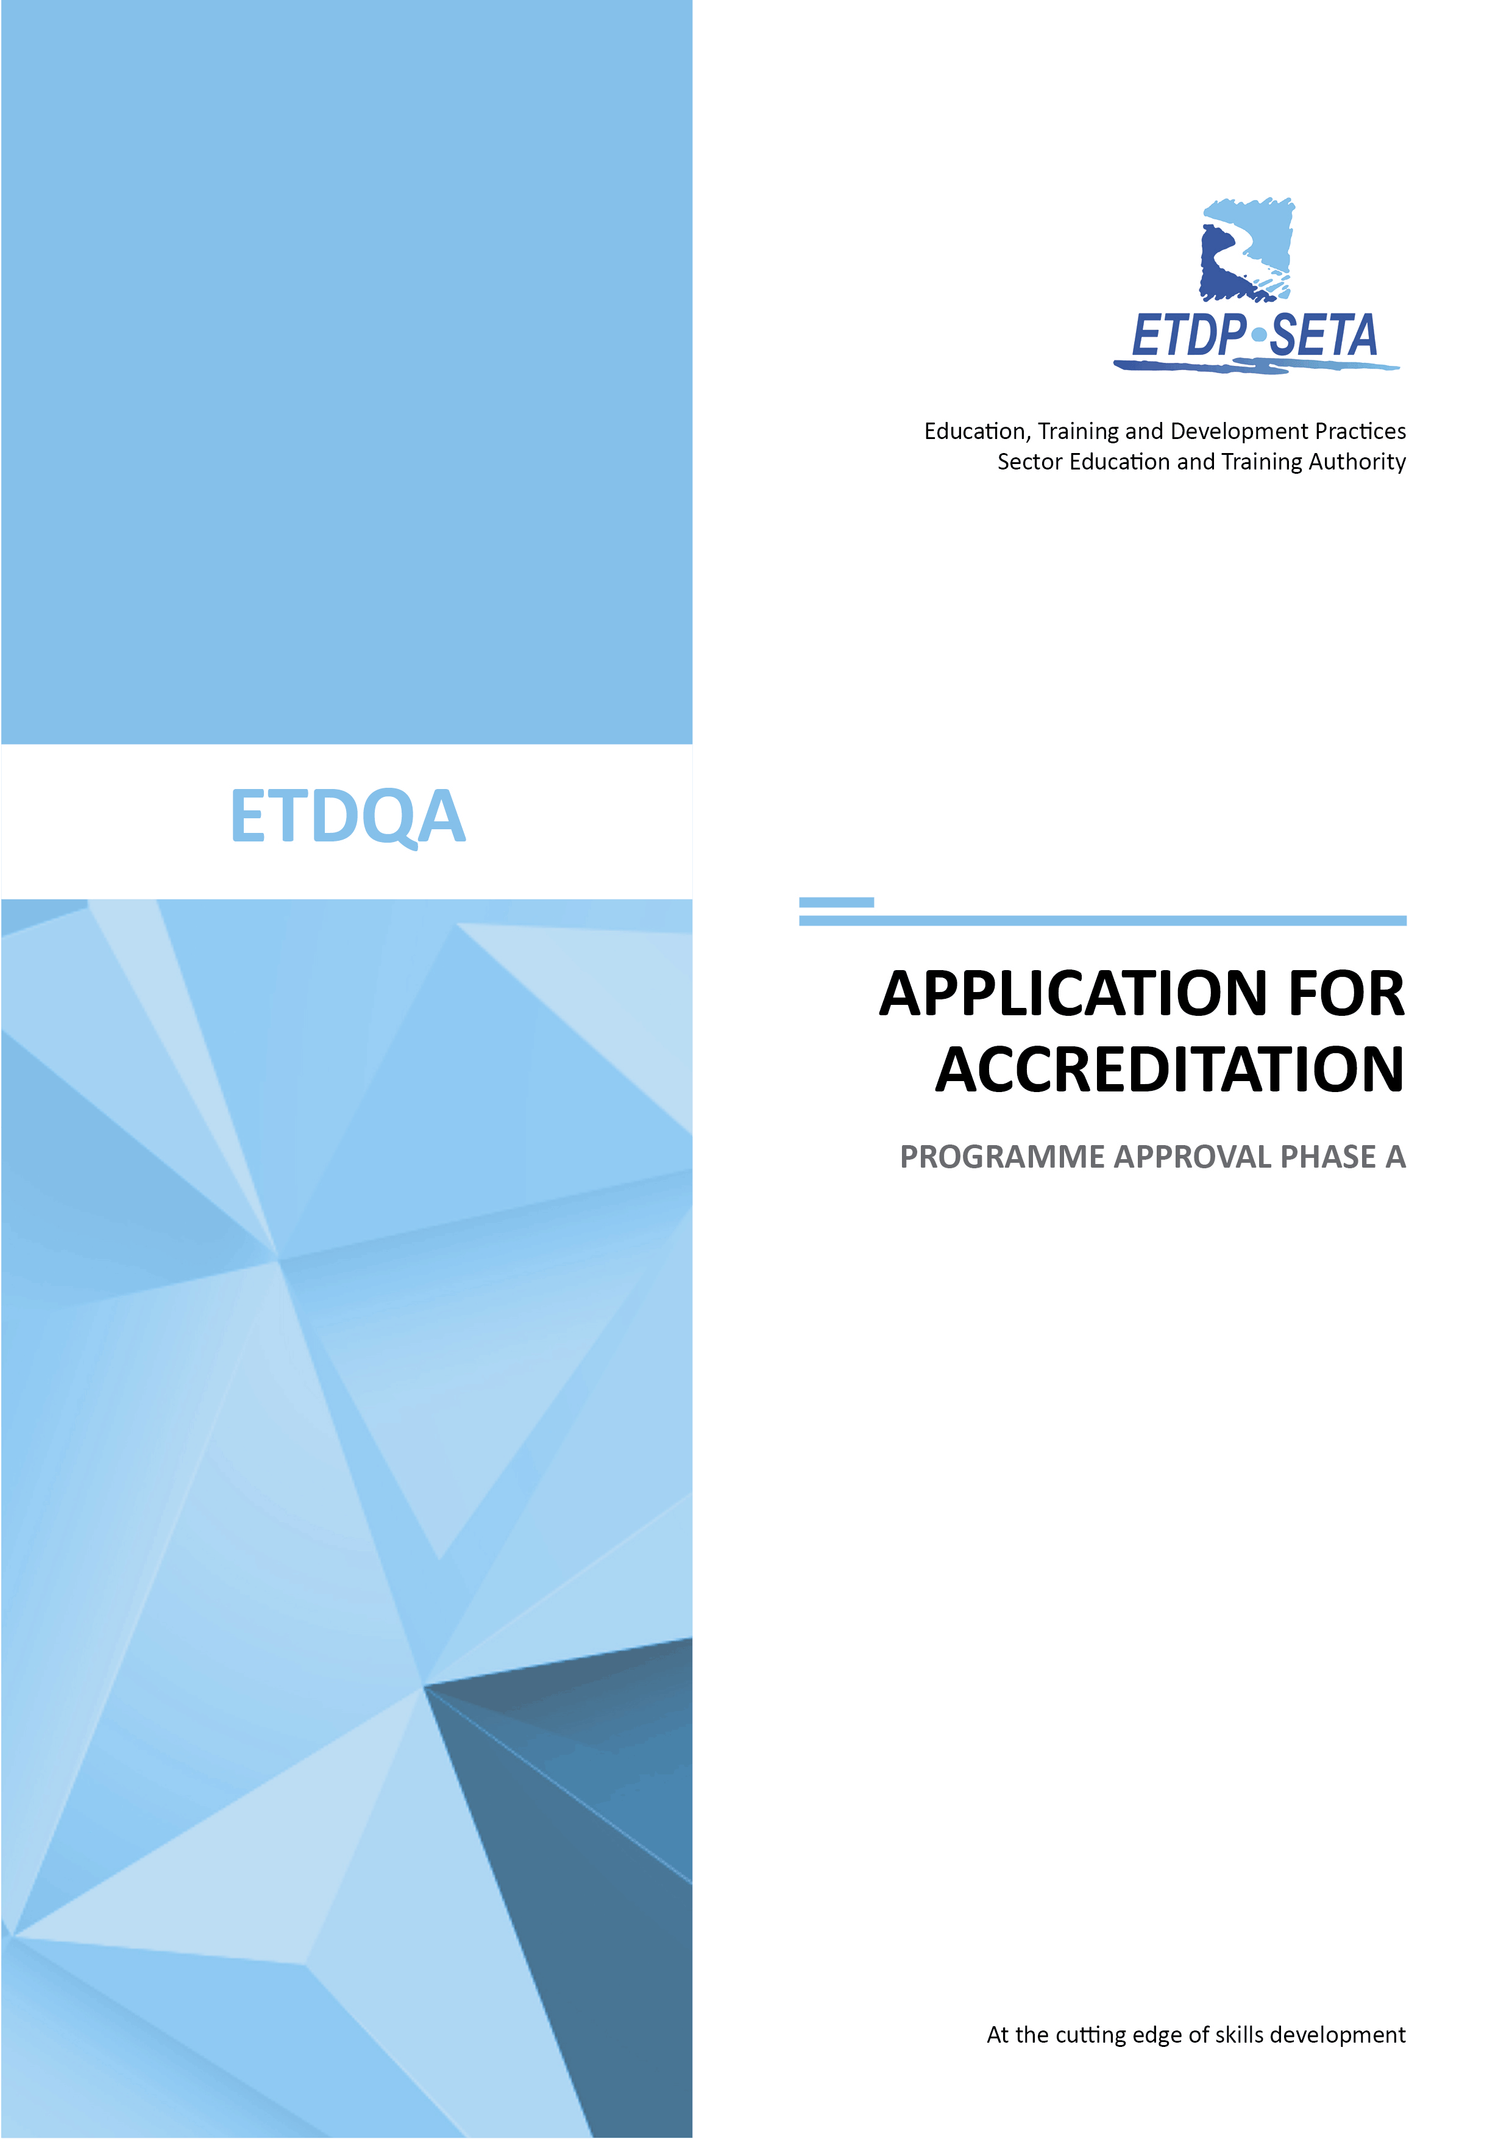
APPLICATION FORM:
PHASE B
Section C: Learning Material Alignment Matrix
From this Section onwards, the Applicant must complete this Application Form for one set of Learning Programme. If applying for more than one learning Programmes, an Application Form must be complete for each learning programme.
C1: Part Qualification Alignment Matrix
If the Learning material was purchased from another SDP, evaluated and approved by the ETDP SETA in the past twelve months from the date of your application submission, please do not complete this section. However, you are required to submit a valid ETDP SETA Learning Programme Approval Letter, which was awarded to the Seller.
Learning Programme Name
Unit Standard Title
SAQA Unit Standard ID Number |  |  |  | NQF Level |  |  | Credit |  | Notional Hours of Learning
Purpose of the Learning Programme
Learning programme Target Audience
Learning Programme Admission Requirements
SO Number | AC Number | Learning programme outcomes |  |  |  | Facilitator Guide |  | Learner Guide | Delivery Method/s | CCFOs Covered
SO Number | AC Number |  |  |  |  | Page No. |  | Page No. | Delivery Method/s | CCFOs Covered

Learning Programme Name
Unit Standard Title
SAQA Unit Standard ID Number |  |  |  | NQF Level |  |  | Credit |  | Notional Hours of Learning
Purpose of the Learning Programme
Learning programme Target Audience
Learning Programme Admission Requirements
SO Number | AC Number | Learning programme outcomes |  |  |  | Facilitator Guide |  | Learner Guide | Delivery Method/s | CCFOs Covered
SO Number | AC Number |  |  |  |  | Page No. |  | Page No. | Delivery Method/s | CCFOs Covered

NB Please duplicate the table above for additional unit standard/s and insert it on this page immediately below this instruction. This instruction is only applicable to integrated part qualification learning programmes.

C2: Full Qualification Alignment Matrix
If the Learning material was purchased from another SDP, evaluated and approved by the ETDP SETA in the past twelve months from the date of your application submission, please do not complete this section. However you are required to submit a valid ETDP SETA Learning Programme Approval Letter, which was awarded to the Seller.
Learning Programme Name
Qualification Title
SAQA Qualification ID No. |  |  |  |  | SAQA Learning Programme ID No. |  |  |  | NQF Level |  |  |  | Credit |  |  | Notional Hours of Learning
Purpose of the Learning Programme
Learning programme Target Audience
Learning Programme Admission Requirements
Module Name |  |  |  |  |  |  |  | Exit Level Outcome
US ID Number | SO Number | AC Number |  | Learning Programme Outcomes |  |  |  | Facilitator Guide |  | Learner Guide |  | Workplace Guide |  |  | Delivery Methods |  | CCFOs Covered
 |  |  |  |  |  |  |  | Page No. |  | Page No. |  | Page No.

Module Name |  |  |  | Exit Level Outcome
US ID Number | SO Number | AC Number | Learning Programme Outcomes | Facilitator Guide | Learner Guide |  | Workplace Guide | Delivery Method | CCFOs Covered
 |  |  |  | Page No. | Page No. |  | Page No. | Delivery Method | CCFOs Covered

NB Please duplicate the table above for additional modules and insert it on this page immediately below this instruction.

Section D: Learnership Alignment Matrix
This section is only applicable and compulsory to a Skills Development Provider that seeks accreditation/ learning programme approval from the ETDP SETA for a full qualification. If the learning material was bought and a valid ETDP SETA Learning Programme Approval Letter was submitted together with this Application Form, you are expected to complete this section
Qualification Title
SAQA Qualification ID No. |  | SAQA Learning Programme ID No |  | NQF Level |  | Credit
Module Name |  |  | Credit | Duration  (Days) | Contact Session % | Experiential Learning % | Notional Hours
Learning Programme Duration

Section E: Assessment Alignment Matrix
E1: Part Qualification Assessment Alignment Matrix
If the Learning material was purchased from another SDP, evaluated and approved by the ETDP SETA in the past twelve months from the date of your application submission, please do not complete this section. However you are required to submit a valid ETDP SETA Learning Programme Approval Letter, which was awarded to the Seller.
Learning Programme Name
Unit Standard Title |  |  |  | SAQA ID No |  |  | NQF Level |  |  | Credit
Learning Programme Alignment |  |  |  | Assessment Strategy
SO Numbers | AC Numbers | Learning Programme Outcomes |  | Knowledge Formative Assessment |  | Simulation Formative Assessment |  | Practical Formative Assessment |  |  | Summative Assessment Tool/s and Instrument/s Exemplar Must be Attached
SO Numbers | AC Numbers |  |  | Page No, |  | Page No. |  | Page No.

Learning Programme Name
Unit Standard Title |  |  |  | SAQA ID No |  | NQF Level |  |  | Credit
Learning Programme Alignment |  |  |  | Assessment Strategy
SO Numbers | AC Numbers | Learning Programme Outcomes |  | Knowledge Formative Assessment | Simulation Formative Assessment |  | Practical Formative Assessment |  |  | Summative Assessment Tool/s and Instrument/s Exemplar Must be Attached
SO Numbers | AC Numbers |  |  | Page No, | Page No. |  | Page No.

NB Please duplicate the table above for additional unit standard/s and insert it on this page immediately below this instruction. This instruction is only applicable to integrated part qualification learning programmes

E2 Full Qualification Assessment Alignment Matrix
If the Learning material was purchased from another SDP, evaluated and approved by the ETDP SETA in the past twelve months from the date of your application submission, please do not complete this section. However you are required to submit a valid ETDP SETA Learning Programme Approval Letter, which was awarded to the Seller.
Qualification Title
SAQA Qualification ID No. |  |  |  |  |  | SAQA Learning Programme ID No. |  | NQF Level |  | Credit |  |  | Notional Hours of learning
Module Name |  |  |  |  |  |  |  | Exit Level Outcome
Learning Programme Alignment |  |  |  |  |  |  |  |  |  | Assessment Strategy
US ID Number | SO Number |  | AC Number |  | Learning programme outcomes |  |  |  |  | Knowledge Formative Assessment |  | Simulation Formative Assessment |  | Workplace Formative Assignment | Final Integrated Summative Assessment Tool/s and Instrument/s Must be Attached
 |  |  |  |  |  |  |  |  |  | Page No. |  | Page No. |  | Page No.

Module Name |  |  |  | Exit Level Outcome
Learning Programme Alignment |  |  |  |  | Assessment Strategy
US ID Number | SO Number |  | AC Number | Learning programme outcomes | Knowledge Formative Assessment | Simulation Formative Assessment | Workplace Formative Assignment | Final Integrated Summative Assessment Tool/s and Instrument/s Must be Attached
 |  |  |  |  | Page No. | Page No. | Page No.

NB Please duplicate the table above for additional modules and insert it on this page immediately below this instruction.

Section F: Education Training and Development Practitioners
F1: Facilitators
Surname | Full Name/s | Qualification/s | Years of Experience | Employment Condition
 |  |  |  | Permanent | Contracted

F2: Assessors
South African ID Number/ Non South African Passport Number |  |  |  |  |  |  |  |  |  |  |  |  | Registration Status |  | Registration Number  (Applicable to Registered Assessors)
 |  |  |  |  |  |  |  |  |  |  |  |  | Registered | Not Registered

F3: Moderators
South African ID Number/ Non South African Passport Number |  |  |  |  |  |  |  |  |  |  |  |  | Registration Status |  | Registration Number  (Applicable to Registered Moderators)
 |  |  |  |  |  |  |  |  |  |  |  |  | Registered | Not Registered

Please take note of the following:
- Facilitator’s qualification/s must be relevant to the Learning Programme for which approval is sought for through the submission of this Application Form.
- An Assessor and/ or Moderator who is/ are not registered with the ETDP SETA, must complete the Assessor and/ or Moderator Registration Form available from http://www.etdpseta.org.za/education/etdqa-documents-and-forms and it must be submitted together with this Application.
- Assessor and/ or Moderator registration, must be against the learning programme for which approval is sought for through the submission of this Application Form.

Section G: Quality Management System
This section is only applicable to Skills Development Providers seeking Institutional Accreditation with the ETDP SETA and are not accredited by any other Quality Assurance Partner and/ or QCTO
Policy and Procedure Name | Submitted
Policy and Procedure Name | Yes | No
Quality Management Policy and Procedure, which include but not limited to:  - Quality management statement, which defines what the SDP seeks to achieve.  - Procedure which will enable the SDP to practice its defined quality management statement.  - Review mechanism which will ensure that the defined quality management statement and procedure are applied and remain effective. | ☐ | ☐
Human Resource Management Policy and Procedure, which include but not limited to:  - Practices for staff selection, appraisal and development.  - Mechanisms for the management of disciplinary and grievance procedures. | ☐ | ☐
Financial Management Policy and Procedures, which include but not limited to::  - Adequate financial resources, demonstrating the availability of necessary financial resources to sustain the learning services throughout the period of accreditation.  - Availability of proper budgetary and financial management processes and allocation of resources adequate to the requirements for providing and developing quality learning services. | ☐ | ☐
Administration and Records Management Policy and Procedures, which include but not limited to::  - Availability of systems and the facilities for maintaining and updating detailed information about past, present and potential learners.  - Ability to report learner records following the required reporting format and procedures.  - Security mechanisms of records and asset management. | ☐ | ☐
Learning Programme Design and Development Policy and Procedure, which include but not limited to:  - Learner entry requirements to various learning programmes offerings.  - Learner guidance to possible learning pathways.  - Learner support mechanisms. | ☐ | ☐

Section G: Quality Management System (cont…)
This section is only applicable to Skills Development Providers seeking Institutional Accreditation with the ETDP SETA and are not accredited by any other Quality Assurance Partner and/ or QCTO
 | Submitted
 | Yes | Yes
Learner Management Policy and Procedure, which include but not limited to::  - Learner support mechanisms.  - Learner appeals mechanisms.  - Learner Code of Conduct. | ☐ | ☐
Workplace Management Policy and Procedure, which include but not limited to:  - Management off-site practical or work-site components where appropriate.  - Learner support mechanisms during experiential learning exposure. | ☐ | ☐
Assessment Policy and Procedure, which include but not limited to:  - Assessment strategies are in keeping with the aims and outcomes of the learning programme as it relates to the outcomes specified in the unit standard and/ or qualification.  - Assessment is inclusive of self-, peer and other forms of group assessment.  - Timing of assessment is flexible in order to accommodate the various and peculiar needs of learners.  - Assessment information is timeously provided to all learners and assessors.  - Records of assessments are kept and learners receive detailed and accurate feedback on their progress and performance.  - Processes and results of assessment fulfil the requirements of the NQF unit standards and qualifications for which the SDP has been accredited for. | ☐ | ☐
Moderation Policy and Procedure, which include but not limited to:  - Roles and responsibilities of the moderator in relation to assessment processes.  - Moderation strategies are in keeping with best assessment principles.  - Moderation process support the review mechanism of learning programme delivery and assessment practices. | ☐ | ☐
Recognition of Prior Learning Policy and Procedure, which include but not limited to:  - Screening of candidates for a RPL programmes  - Access to learning programme when a learner does not meet the learning programme admission requirements.  - Award of the credits to qualifying candidates who have gone through the RPL process.  - Learner advisory support mechanisms.  - Administration of RPL processes.  - Management of assessment and moderation processes. | ☐ | ☐

Section H: Documentary Evidence
Section | Applicability |  | Attached
Section | Institutional Accreditation | Extension of Scope | Yes | No | Not Applicable
Section B: Learning Materials  - Valid Purchase Agreement. | Yes | Yes | ☐ | ☐ | ☐
- Valid ETDP SETA Learning Approval Letter. | Yes | Yes | ☐ | ☐ | ☐
Section C: Learning Alignment Matrix  - Learner Guide.  - Facilitator Guide.  - Workplace Guide. | Yes | Yes | ☐ | ☐ | ☐
Section D: Learnership Alignment Matrix  Below evidence requirement is only applicable to an Applicant that submitted a Valid ETDP SETA Learning Programme Approval Letter for another SDP.  - Workplace Guide.  - Formative Assessment Guide.  - Exemplar of Final Summative Assessment Tools and Instruments. | Yes | Yes | ☐ | ☐ | ☐
Section E: Assessment Alignment Matrix  - Assessment Guide.  - Moderation Guide.  - Portfolio of Evidence Guide. | Yes | Yes | ☐ | ☐ | ☐
- Exemplar of Summative Assessment Tools and Instruments (Part Qualification Only). | Yes | Yes | ☐ | ☐ | ☐
- Exemplar of Final Summative Assessment Tools and Instruments (Full Qualification Only). | Yes | Yes | ☐ | ☐ | ☐

Section H: Documentary Evidence (cont…)
Section | Applicability |  | Attached
Section | Institutional Accreditation | Extension of Scope | Yes | No | Not Applicable
Section F: ETDP Practitioners  - Facilitator’s Qualification/s.  - Facilitator’s CV.  - Facilitator’s contract of employment.  - Assessor’s contract of employment.  - Moderator’s contract of employment. | Yes | Yes | ☐ | ☐ | ☐
Section G:Quality Management System  - All Policies and Procedures contained under this section. | Yes | No | ☐ | ☐ | ☐

Section I: Declaration and Signatory
I1: Declaration
I, the undersigned, on behalf of [Type here] (Skills Development Provider) declare that I have full authority to sign this “Application Form” on behalf of the entity and that the details provided herein are true and accurate.
I2: Signatory
Name & Surname
Position
Place
Signature
Date | d | d | m | m | y | y | y | y

Submissions:
SDPs are directed to submit their applications for the Face-to-Face Accreditation by email to accreditation@etdpseta.org.za

For Office Use Only
Comments:
Application Compliance
Recommended for Evaluation |  | Yes ☐ No ☐
Verified by
Signature
Date | d |  | d | m | m |  | y | y | y | y

